SBIG 16803 Backfocus Optimisation

# Background

An SBIG 16803 was purchased back in 2020, with the aim of doing deep sky astrophotography with a Celestron C14 EdgeHD at Prime Focus. The large sensor (35mm x 35mm) with large pixels (9 microns) gives a relatively large FOV (0.5 deg x 0.5 deg) and a good image scale of 0.54 arc secs per pixel.

It was understood that the guaranteed image circle of the Celestron of 40mm meant that the sensor diagonal (~50mm) would be outside this specification, making it important that the set back distance was as close to optimal as possible, with the aim of having the best possible star shapes in the corners of the image.

# Adaptor Design

It was necessary to determine the size of the Adaptor in the imaging train which would give the correct back focus distance. It was decided to size the adaptor to be 1mm shorter than this to allow spacers to be inserted to optimise the setback distance.

Initial calculations determined that theoretically a 51mm set back distance was required, so a 50mm adaptor was required with the 1mm allowance for adjustment.

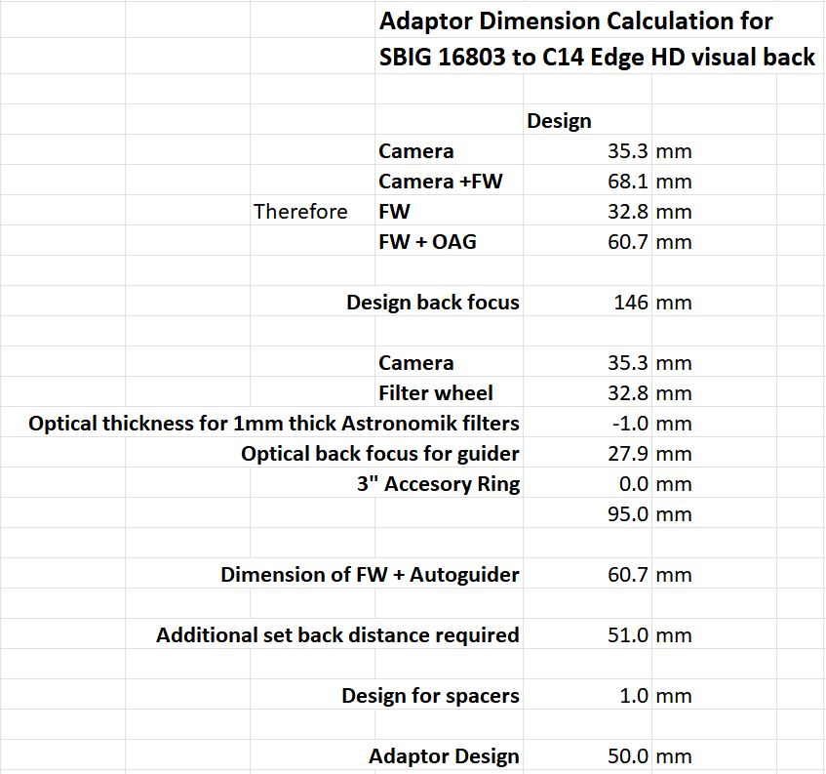

A 50mm adaptor was procured from Precise Parts

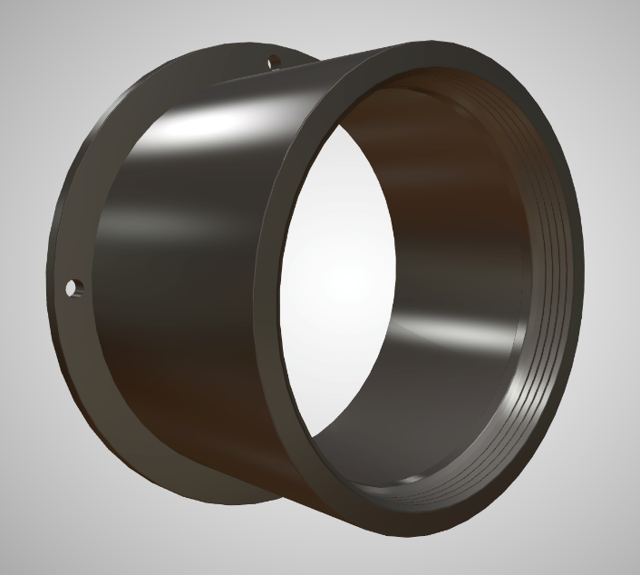

Initial trials were conducted, and the stars were elongated to a greater or lesser extent right across the FOV. After much investigation it was determined that vibration from the fan supplied with the camera was causing the elongation. A new low vibration fan was installed to solve the problem. It then became possible to identify any real issues associated with tilt or field curvature.

Diffraction Limited Pty Ltd, to their credit, supply the cameras pre-adjusted for tilt. The one supplied was determined to not require adjustment and in practise the sensor was determined to be flat. i.e. there was no differential elongation in each corner. This was a major benefit as no shims, or the like were required to optimise performance.

# Initial Trials

The initial trials were carried out at the design with the 50mm adaptor and a 1mm spacer which was also sourced from Precise Parts. Additionally, a set of spacers made as follows to allow for fine set back distance adjustment. These were designed to fit the camera:

|  |  |  |  |  |
| --- | --- | --- | --- | --- |
|  | 20 | thou | 0.508 | mm |
|  | 8 | thou | 0.2032 | mm |
|  | 5 | thou | 0.127 | mm |
|  | 4 | thou | 0.1016 | mm |

The initial trials showed radially elongated stars in the corners, suggesting that the image train was too long and that spacers needed to be removed. Unfortunately, after removing all the spacers and just having the 50mm adaptor, the stars were still radially elongated. The adaptor was therefore too big.

On rechecking the design, it was determined that although the Astronomik Filters which are 1mm thick were specified as having an optical thickness of -1mm focal, in fact, it seems more likely that the optical thickness was more like -0.3mm. This is in line with the conventional wisdom that the optical thickness of a filter is 1/3rd its actual thickness. It was also determined that the actual length of the image train was ~ 1mm longer than the specification, most likely due to manufacturing tolerances.

The following redesign with actual dimensions was made:

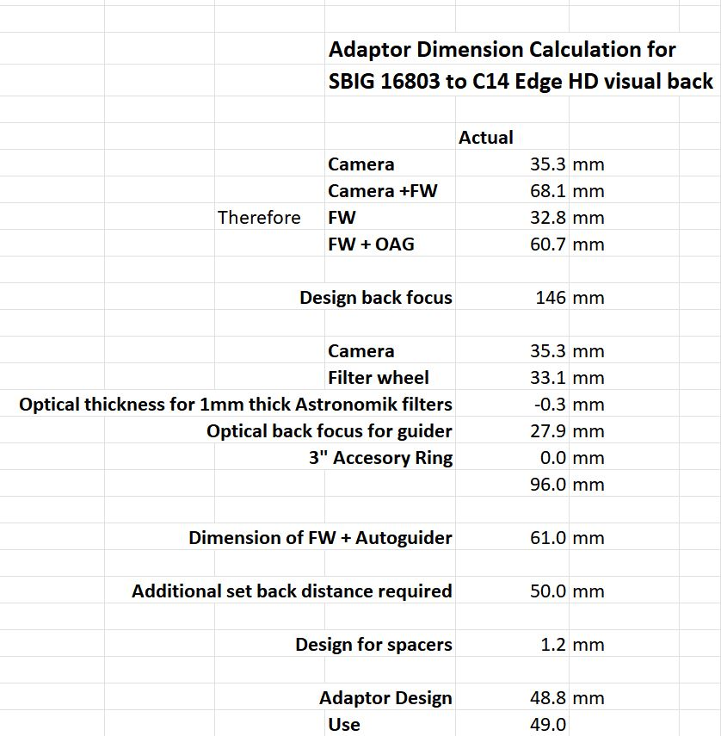

From this it was determined that a 49mm adaptor was required and another was sourced from Precise Parts with this dimension.

# Trials with the new 49mm adaptor

A series of trials were undertaken with the new adaptor and the star shapes were determined to be satisfactorily round with a 1mm spacer plus two 8 thou (0.2mm) spacer. Therefore, the total spacing on top of the 49mm adaptor was 1.4mm. Exactly why the 50mm adaptor alone didn’t deliver a satisfactory outcome is unknown. Perhaps it was temperature related. In any case the 50mm adaptor was too close to the wind and the use of the 49mm adaptor gave much better scope for adjustment as necessary.

# Change to the C11 EdgeHD

In 2022, the C14EdgHD was mounted alongside an existing C11EdgHD, atop a Paramount MEII Mount. This allowed the C14 to be dedicated to visual observing, planetary imaging or subsequently to Schmidt Focus (f/1.9) imaging. Meanwhile the SBIG 16803 was paired with the C11 and dedicated to Prime Focus Deep Sky imaging. The new set up has a larger FOV (0.75 deg x 0.75 deg) at the slight penalty in image scale, now 0.66 arc secs per pixel versus 0.54 arc secs per pixel previously.

Theoretically, the C11 and the C14 have the same back focus distance of 146mm, so it was hoped that the same spacing would deliver the right setback distance and give good star shapes across the image.

At the time of the change over the initially trials indicated that the star shapes in the corners were pretty good but not perfect and it was decided to not make any adjustment at that time, recognising that any defects were readily sorted out by BlurXTerminator.

# Further optimisation

It was clear from the outset that the setback distance could be improved. The stars were concentrically elongated in the corners.

The following Aberration Inspector report from an image of Centaurus A shows the stars in the centre and corners. The following image is 4x4 panel. The stars are pretty good, but it can be seen that in the corners they are slightly concentrically elongated. In most instances BlurXTerminator was fixing this issue, however, it is also recognised that the less one has to use processing technology to sort out defects the better.

## 4x4 Aberration Inspector Image

and for the 3x3 grid the defects are clearer to see.

## 3x3 Aberration Inspector Image

By mid-2024 the decision was taken to adjust the spacing to fine tune it. The autofocus routine gave a good clue as to what adjustments needed to be made. As the autofocus routine was running, the focuser would wind the focus out and then push the mirror upwards decreasing the focal length. This is best practise as it means the mirror is being positively engaged by the focuser as it is stepping through the focus positions. At each focal position capturing images to determine the mean HFR.

It was noticed that as the autofocus stepped through the points of focus measurement, 300 steps apart, the corner stars went from elongated concentrically to round to elongated radially. This was a very visual demonstration of this field curvature effect. Generally, when the stars are elongated concentrically the image train is too long and radially too short. In this case the focuser, as stated previously, always pushes up against the mirror as it goes through its focus steps, so it is always starting too long and it makes perfect sense that the first autofocus images show concentric elongation, then round and then radial elongation. However, the corner stars were round, one focus step of 300 from the best focus position. Therefore, at the best focus position the stars were slightly elongated in the corner, but 300 steps further in, they were round, but now the centre stars were slightly out of focus.

The following 3 images show the bottom right-hand corner of the image. Here at left, when the image was "in focus" they were elongated concentrically, then 300 steps later (middle image) they were round, but the image was now slightly out of focus and then, 300 steps further in they were radially elongated. 300 steps, at 1.3 microns per step corresponds to 400 microns or 0.4mm. So, this implied that the setback distance was too long by 0.4mm.

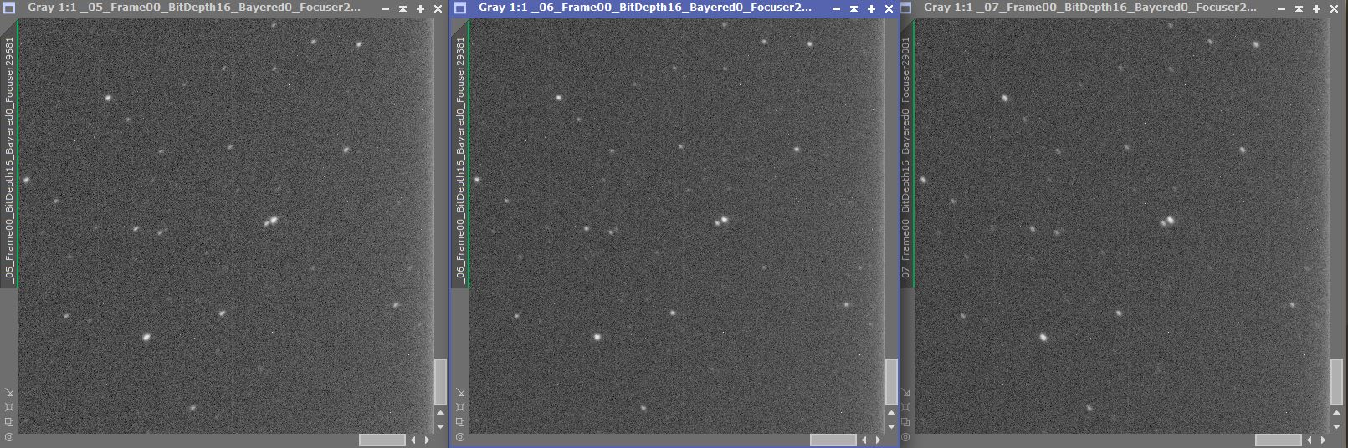

The two x 8 thou (0.2mm) spacers were removed.

# Final Result

It was nice that the first iteration completely eliminated the elongation. The spacer removal as calculated from the autofocus data proved to be perfectly correct. This was the result from the Aberration Inspector report after the adjustment:

## And the 3X3 Panel Aberration Inspector Image:

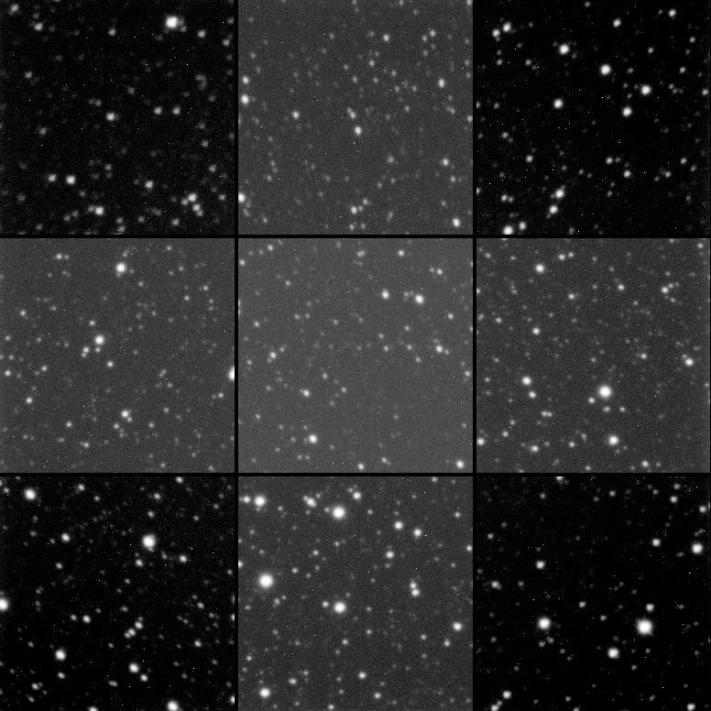

The stars are practically perfect, and this is certainly a very good result considering the corners are outside Celestron’s maximum image circle specification.

This is the before and after:

Before & After Adjustment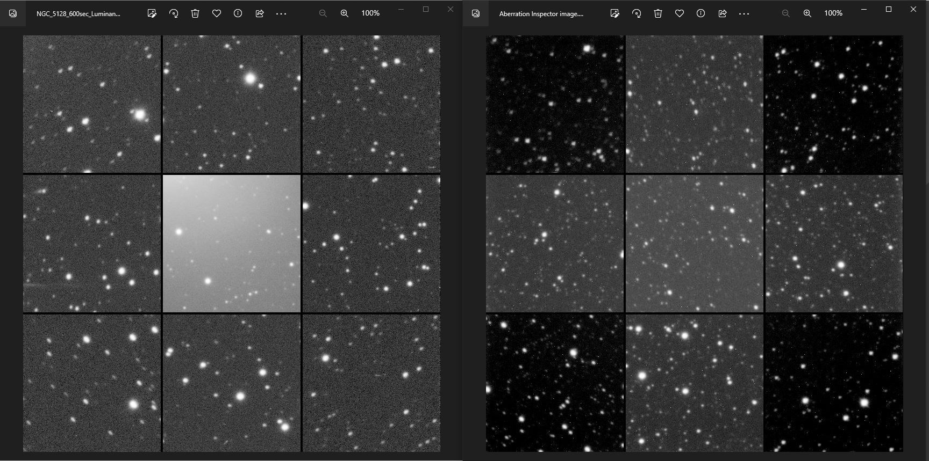

ASTAP Tilt analysis:

